**Create-Profile Page : Steps**

can u design the model class for this profile form?

can u create a component called create-profile component? yes ==> in which module ===> profile

api for this form :

// @route POST /api/profile :

// @desc Create or edit user profile

// @access Private : it requires token ===> jwt-token interceptor.

can u create a service called profileService ? yes ===> where ==> profile module

can u create a service method called createProfile() inside the profileService of profile module? yes

can u register the service in profile module ?==> providers []

can u consume the createProfile service method inside the create-profile component? DI

can u render the error messages which are coming from rest call?

Add-Experience Page : /// Add-Education :

can u design the model class for this add-Experience form?

can u create a component called add-Experience component? yes ==> in which module ===> profile

api for this form :

// @route POST /api/profile/experience

// @desc Add experience to profile

// @access Private ===> token ===> jwt-interceptor

can u create a service called profileService ? yes ===> where ==> profile module

(already created)

can u create a service method called addExperience() inside the profileService of profile module? yes

can u register the service in profile module ?==> providers [] ===> done at the time of create-profile component.===> already done at the beginning.

can u consume the addExperience() service method inside the add-Experience component? DI

can u render the error messages which are coming from rest call?

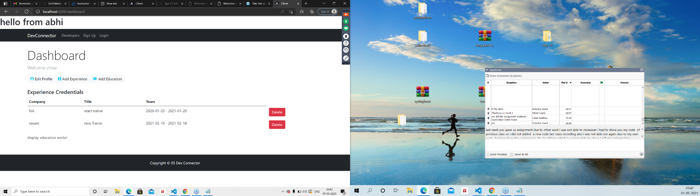

Problems : **1. After login we don’t want to see sign in and sign up buttons. ===> SubjectService⇒ predefined service.**

**2. If i will hit register/ login then it should take me to the dashboard when i have a valid token.**

**3. Do we need to log out ?===> yes ====> it should remove all local storage content and should redirect to the login page.**

4. Testing

5. Deployment ====> docker env. And heroku app server.

**6. When u r logged in or if you have a valid token then if you will click on devconnector then it should take to the Dashboard.**

**7. How to generate the build for our application?**

**Ng Build**

Testing :